Project Report

Product Name | Advanced Certificate in Web Development
Qualification Name (ITSF) | NICF-Advanced Certificate in Infocom Technology (Software & Applications)
Product Name | NICF-UI Frameworks
Module Name (ITSF) | NICF-UI Frameworks

Student name |  | Assessor name
Viddy Virstandi P.A.P
Date issued | Completion date |  | Submitted on
13 July 2022 | 14 July 2022 |  | 14 July 2022
Project title | Design & Develop Front End Community Portal RIA application.

Learner declaration
I certify that the work submitted for this assignment is my own and research sources are fully acknowledged.
Student signature: Date: 13 July 2022

Content
- Project background
- Project Objectives
- Business Process & Solution Architecture
- Task 1
- Task 2
- Task 3
- Task 4
- Task 5
- Task 6
- Task 7
- Task 8
- Task 9

Project Background
ABC Jobs Pte Ltd as a website developer to develop a community portal for Software Developers. The Scope of the Project is to design a Community Portal Similar to Linkedin.com. Users will be able to register in the portal using the Registration Page. Users of the portal can search for other users using various parameters such as First Name, Last Name, Company Name, City & Country. Users will be able to view the Public Profile of users after searching them.
The portal allow users to login, request for forgotten password and Update their profile information The scope of the project in this modules is for development of GUI front end using HTML, Javascript, CSS & Angular.

Project Objective
The software programmers of ABC Jobs Pte Ltd make the prototype of what the Community Portal need
The portal consist of the following Key pages (For Reference)
    - Community Portal Home Page
    - Registration Page
    - Registration Confirmation Page
    - Update Profile Page
    - Search Users Page
    - List Search Results
    - Public Profile Page
    - Registration Confirmation Email
    - Login Page
    - Forget Password Page
    - Design the Forget Password Confirmation Page

Tools & platform used
To make that following page above, the developers will need some tools and platform to support them.
The tools and the platform are :
- Visual Studio Code
Visual Studio Code, also commonly referred to as VS Code, is a source-code editor made by Microsoft for Windows, Linux and macOS. Features include support for debugging, syntax highlighting, intelligent code completion, snippets, code refactoring, and embedded Git.

- Axure RP 10
Axure RP 10 is a software for creating prototypes and specifications for websites and applications. It offers drag and drop placement, resizing, and formatting of widgets.
- Chrome
Chrome is a free Internet browser officially released by Google on December 11, 2008. Its features include synchronization with Google services and accounts, tabbed browsing, and automatic translation and spell check of web pages. It also features an integrated address bar/search bar, called the omnibox.
- Angular CLI
The Angular CLI is a command-line interface tool that you use to initialize, develop, scaffold, and maintain Angular applications directly from a command shell.
- Diagrams.net (formerly Draw.io)
diagrams.net (formerly draw.io) is free online diagram software. You can use it as a flowchart maker, network diagram software, to create UML online, as an ER diagram tool, to design database schema, to build BPMN online, as a circuit diagram maker,
and more.

Business Process & Solution Architecture
Flowchart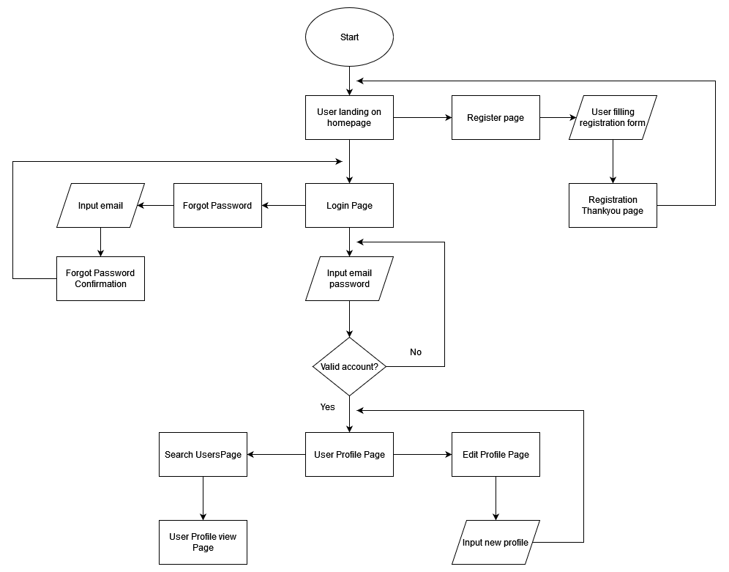
User come to landing page, at the landing page user can login by clicking the login button on ther right corner of the website or on the hero banner login form.
If the user does not have any account yet, the user can register first by clicking at register button. After registration done user will be redirected to registration thankyou page and now have an account to logged in to the website.
If the user forgot their password, they can request a password retrieval by clicking the forgot password button. User input their email and will be redirected to forgot password confirmation and they will get link to their email for resetting the password.
User login to the website and redirected to their respective profile page, user can edit their profile page by clicking the edit profile button. User can search another user profile page by clicking the people button in the navigation bar at the top of the website. After clicking the people button the user will be redirected to search user page, user can search user by their name, country, city, and company. List of user will appear when searching in the search user page, user can click any of the users list and will be redirected to that user profile view page.

Wireframe pages | Specifications (Widget Table)
Login  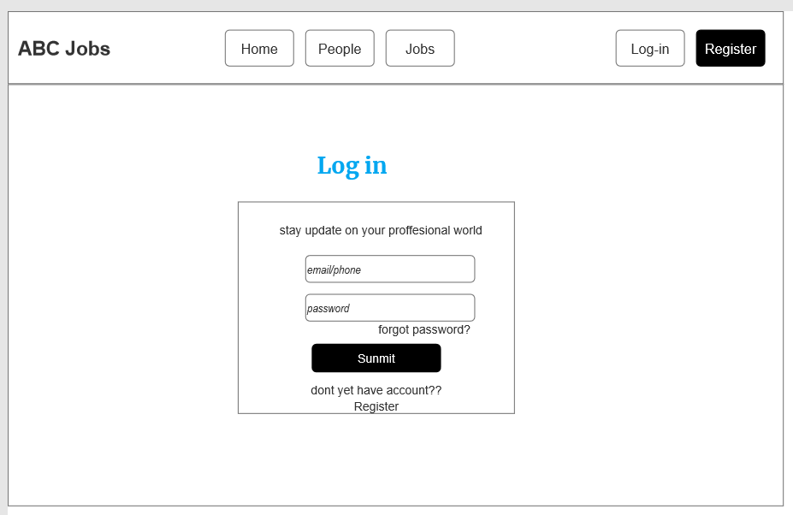 | Note number Name Interactions  1 Login form  2 Forgot password link Click or tap go to link  3 Login button Click or tap Go to link  4 Login with google button  5 Register link Click or tap Go to link
Register  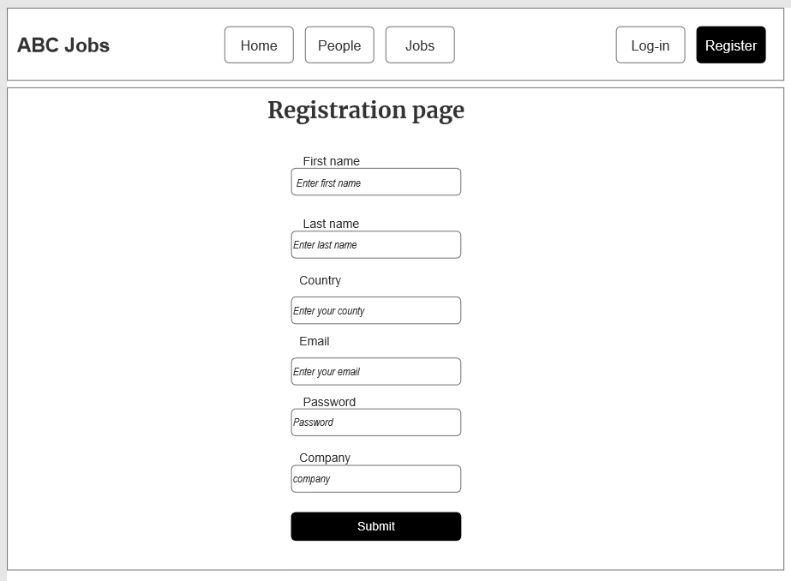 | Note number Name Interactions  1 Register form  2 Register button Click or tap go to link
Forgot Password  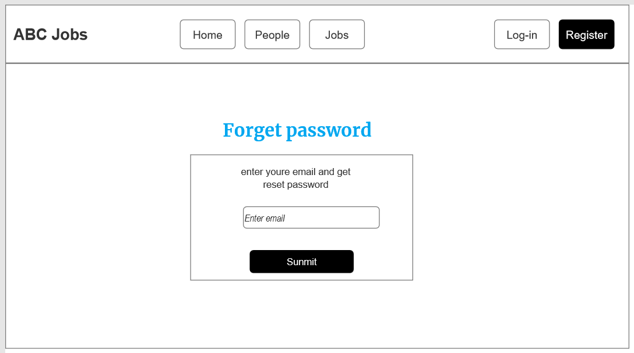 | Note number Name Interactions  1 Forgot Password form  2 Submit button Click or tap go to link  3 Back to login Click or tap go to link
Edit Profile  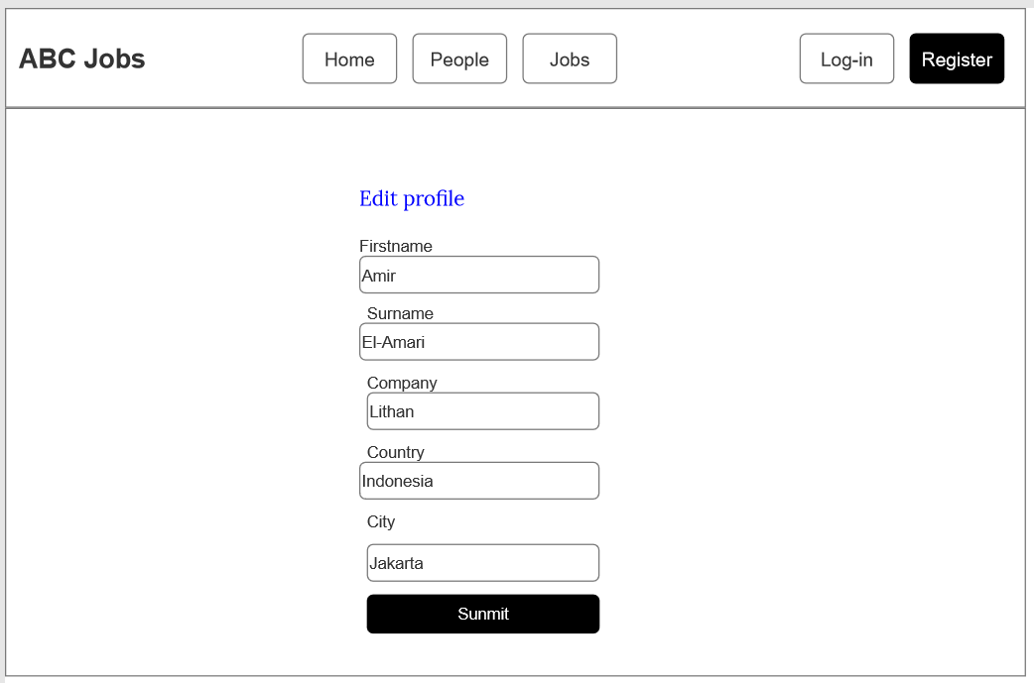 | Note number Name Interactions  1 Edit profile form  2 Save button Click or tap go to link
Search user  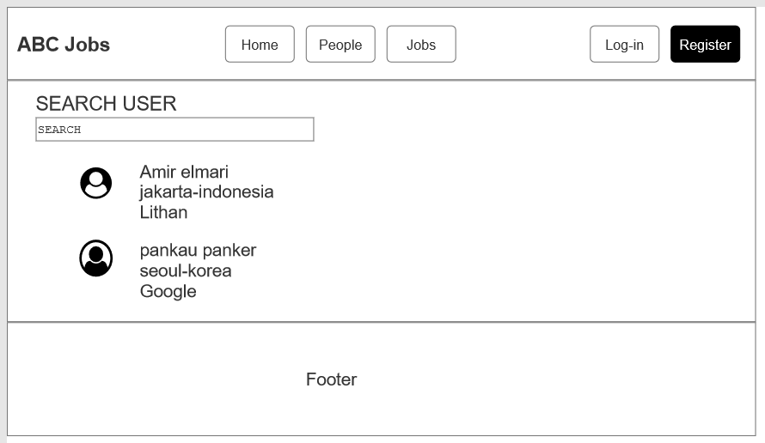 | Note number Name Interactions  1 Search bar  2 Lists of user Click or tap go to link  3 Profile picture

- Task 1

Task Statement:

  - Briefly explain techniques and methods for gathering and analyzing user feedback.
  - Find at least 2 websites which are similar to community portal and visit and use them and record your experiences.
  - Include it as part of Project Presentation

Solution:
There are two ways to collecting the data, quantitative and qualitative
Quantitative data is collecting the data base on the similarity
- Surveys, tests, or questionnaires – administered in groups, one-on-one, by mail, or online;
- Reviews of records or documents using a rubric; or
- Observations.

Qualitative data is collecting and analyze the data
- Shadow Sessions (Observe the user when using the program)
- A/B Testing (Compare between two programs and decide which one is better)
User Experience on 2 community portal websites

- Linkedin.com
When I go to linkedin.com website, my eyes instantly looking for the beautiful palette color combination. The text also easy to read and easy to find what I want to do. After that I tried to register by clicking the “join now” button. The registration form was good and easy to fill with validation on it to prevent user error. After register I login and it was pretty smooth transition page to page. I like the flow of the website.

- Jobstreet.co.id

When I go to jobstreet.co.id website, the home page is not really good, there not much information when I first arrive on the website. I tried to register to the website but I don’t see any register button but instead there is “masuk” button written with Bahasa means “go in” or like login. I tried to click that button and find the register button from there. Finally I got the register button and filling up the form. They also provide way to register with Facebook that’s speed up the registration progress for me. After that I tried to login to the website and overall the layout and color of the website is very good and I like the color too.

Task 2

Task Statement:
  - Discuss, study and analyze the user experience based on the observations done in Task 1.
  - Study the experience for 2 to 3 scenarios.
  - Include it as part of Project Presentation

Solution:

Scenario :
Register Page
Registration scenario in linkedin.com is very good experience. The way the registration form first pop up was displaying 2 fields that are email and password, this way the user will experiencing not much form at the same time and not being bored fast. The validation also good giving user warning that their inputting invalid or wrong data. Linkedin.com also provide registration with google, it fasten the process of register to the website. The color of the page is beautiful and simple.

Login Page
Login scenario in linkedin.com provide “show” password feature, so the user can easily if they typing the correct password. The login page also provide forgot password that is very good for user that forgot their password. Linkedin.com login page also has feature for remembering the login history, so when you logout and want to login again you just click on your previous account and you just need to typing password once again and login to the page.

2

Task 3

Task Statement:
- Identify the performance level & gaps between user experience & desired user experience along with level of user engagement
- Measure the level of user engagement & stickiness with the product.
- Document it as part of Project Report

Solution:

LinkedIn.com
Scenario | TOT (seconds) | Expect TOT | Performance Gaps | UER
Register | 65 | 60 | 65 | 2
Login | 18 | 20 | 2 | 0
Jobstreet.co.id
Scenario | TOT (seconds) | Expect TOT | Performance Gaps | UER
Register | 50 | 60 | 10 | 0
Login | 30 | 20 | 10 | 2

Task 4

Task Statement:
- Develop & document 3 metrics to measure the user experience.
- Create Bootstrap HTML along with angular pages for the proposed pages and get feedback from mentor and document them.
- Document it as part of Project Presentation

Solution:

Included in the project presentation

Task 5

Task Statement:
- Create the steps in User Interaction process for various scenario.
- Create a flow chart for user interaction.
- Document it as part of Project Presentation.

Solution:
Included in the project presentation

Task 6

Task Statement:
- In the Websites study’s get the general user response from one other user.
- Document the general user response to the product as part of Project Presentation.

Solution:
Included in the project presentation

Task 7

Task Statement:
- Create a Prototype for the proposed system, with at least 5 screens
- Get the user response and classify them to various types.
- Screen capture the prototype and include it as part of Project Presentation.

Solution:
Included in the project presentation

Task 8

Task Statement:
- Gather feedback for the prototypes and document, make suggestions for improvement.
- Make suggestions to improve the user experience and implement them in the prototype
- Include it as part of Project Presentation

Solution:
Included in the project presentation

12.Task 9
Task Statement:
- Create 3 usability tests and test them with users.
- Get the users use the modified prototype
- Gather feedback and measure its technical viability and effectiveness
- Include it as part of Project Report

Solution:
Task: Register for an
account
Participant Name | TOT  (seconds) | UER | TSR | Observation | Feedback
Bobi Suherman | 47 | 1 | 1 | Typing invalid email | No feedback
Yusuf | 53 | 2 | 1 | Not entering for last-name and company | The last name should be optional
Marinka Aisa | 39 | 0 | 1 | All good | No feedback
Alex Sulivan | 41 | 0 | 1 | All good | No feedback
Jhon Doe | 43 | 0 | 1 | All good | No feedback
 | TOT | UER | TSR
Average Score | 44,6 | 8,57% | 100%
Improvements
- make sure all the fields are supposed to be required

Task: Log into the portal with registered email

Participant Name | TOT  (seconds) | UER | TSR | Observation | Feedback
Bobi Suherman | 33 | 1 | 1 | Wrong password | Please add show password
Yusuf | 21 | 0 | 1 | All good | No feedback
Marinka Aisa | 16 | 0 | 1 | All good | No feedback
Alex Sulivan | 62 | 2 | 1 | Wrong password and invalid email | No feedback
Jhon Doe | 18 | 0 | 1 | All good | No feedback
 | TOT | UER | TSR
Average Score | 30 | 30% | 100%
Analysis & Suggested
- password input field not yet been added a show password feature
Improvements
- adding show password feature

Task: Update Profile
Participant Name | TOT  (seconds) | UER | TSR | Observation | Feedback
Bobi Suherman | 32 | 0 | 1 | All good | Maybe add edit profile picture
Yusuf | 52 | 1 | 1 | Trying to delete lastname but can’t because last name was required | No feedback
Marinka Aisa | 44 | 0 | 1 | All good | No feedback
Alex Sulivan | 32 | 0 | 1 | All good | No feedback
Jhon Doe | 20 | 0 | 1 | All good | No feedback
 | TOT | UER | TSR
Average Score | 36 | 2,8% | 100%
Analysis & Suggested
- adding edit profile picture

CSAT | Question: On a scale of 1 to 10 (1 being least satisfied, 10 being most satisfied), <How good the website overall>? And Why?
 | Participant Name | Satisfaction Score | Reason
 | Bobi Suherman | 9 | Good color palette
 | Yusuf | 7 | Simple UI design
 | Marinka Aisa | 10 | Cool website
 | Alex Sulivan | 8 | Good website
 | Jhon Doe | 8 | I like the color
 | Average CSAT Score | 8,4
NPS | Question: On a scale of 1 to 10(1 being least, 10 being highest), <How willing you promote the website>? And  Why?
 | Participant Name | Promoting Score | Reason
 | Bobi Suherman | 9 | Good functionality
 | Yusuf | 5 | Could be improved at some point
 | Marinka Aisa | 9 | I like the website flow
 | Alex Sulivan | 8 | Easy to read
 | Jhon Doe | 7 | Cool website
 | NPS | 40%

